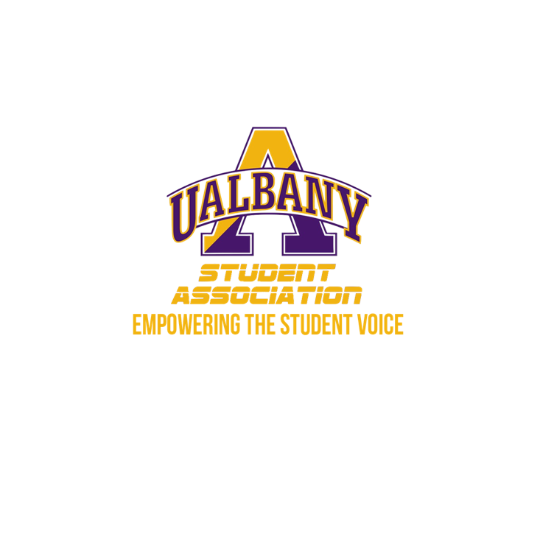

Student Association Board of Finance
Meeting Agenda
December 8th, 2019 – 5 PM
The HUB Conference Room

- Call to Order and Roll Call
- Approval of the Minutes
- Public Comment
- Chairs’ Report
  - Samuel Salazar, Chairman of the Board of Finance
  - Molly Donelan, Vice-Chairwoman of the Board of Finance
- Comptroller’s Report
  - Tony Kelley, Comptroller
- Senate Report
  - Sabra Simon, Chair of the Appropriations Committee
- Budgetary Business
  - Rescheduling of the Mandatory Budget Meeting
- Unfinished Business
  - NLCC Contract
- New Business
  - Time Sensitive Contract
  - Financial Investigation into Credit Cards
- Closing Roll and Adjournment

