Senate Bill 1213-04

UNIVERSITY SENATE

UNVERSITY AT ALBANY
STATE UNIVERSITY OF NEW YORK

Introduced by: CAS/Women’s Studies Department

Date: March 11, 2013

NAME CHANGE FOR OF WOMEN’S STUDIES DEPARTMENT

IT IS HEREBY PROPOSED THAT THE FOLLOWING BE ADOPTED:

- That the change becomes effective in the fall of 2013.
- That this proposal be forwarded to President Robert J. Jones for approval.

TO: Andi Lyons, Chair
University Senate
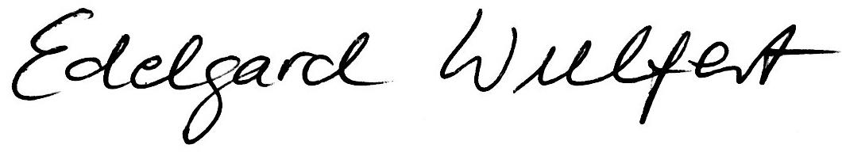
FROM: Edelgard Wulfert, Dean
College of Arts and Sciences

DATE: February 8, 2013

RE: Change in name of Women’s Studies Department

Following is a request from the Women’s Studies Department to change its name to the Department of Women’s, Gender and Sexuality Studies. The rationale is clearly laid out in the document and I fully endorse the faculty’s request.

As with similar name changes, we typically have presented such requests to the University Senate. I would therefore appreciate if you would forward this request with my endorsement to the respective Senate Council/Committee for consideration.

TO: Edelgard Wulfert, Dean

FROM: Vivien Ng, Department Chair, Women’s Studies

DATE: January 2, 2013

RE: Request to Change the name of the Women’s Studies Department

WOMEN’S STUDIES DEPARTMENT NAME CHANGE PROPOSAL
RATIONALE

The Women’s Studies Department faculty members have voted unanimously to change the name of the Department to Women’s, Gender and Sexuality Studies. The reasons for the proposed name change include the following:

- The interdisciplinary field that started as Women’s Studies has undergone significant transformations since its inception in the early 70s. From an early emphasis on recovering, researching, and teaching about women’s neglected experiences and histories, as well as the social contexts and inequalities that structured their lives, the field has expanded to emphasize the investigation of gender as a system shaping not only women’s lives, but also the lives of men and people who do not fit neatly into binary sex/gender categories, including intersex, transgender, and other gender non-conforming individuals. The connection between gender non-conformity and diverse sexualities defying heteronormativity also became a focal point, partly reflected in the growing importance of queer studies. Scholarship that applies a gender lens to look critically at constructions of masculinity has also experienced significant growth in the field.

The UAlbany Women’s Studies department has been influenced by and participated in shaping these trends in the field. However, while the department curriculum has changed over the years in ways that reflect such transformations, the name of the department remained the same. The proposed name change is a move to better reflect what the department is already doing, and in this way, we aim to more accurately convey the content of the programs we offer and bring the department’s name to the 21st century. A number of reputable departments and programs across the nation now bear our proposed new name, for example, at Yale University, Harvard University, Northeastern University, Emory University, University of Cincinnati, and Boston College, among others.

- By keeping “Women,” in the title we recognize the historical roots of the field and the impetus it gained from the women’s movement, as well as naming what is still a central part of the curriculum. Yet, by including “Gender” and “Sexuality,” we signal how the field has grown to be more inclusive, which is the case for our department, too. The name change communicates a “shift away from binary identity politics in which a single category (women) can represent the complexity of experiences of individuals and groups who experience gender differently based on their race, ethnicity, sexuality, age, ability, or social class” (Berger and Radeloff 2011:43). We believe that as a result of reflecting more accurately the kind of inclusive curriculum we are already offering, more students (who have perhaps been unaware of how their interests match those of the department) may now be encouraged to major in Women’s, Gender and Sexuality Studies or enroll in our MA program.
- The claim that the department is already covering the topics and approaches conveyed by the new name can be easily verified by examining our existing undergraduate and graduate curriculum. All of our core courses (WSS 100, 240, 360, 490, 492, 590 & 565), regardless of official course title, include the teaching of gender and sexuality, and this is also the case for many of the elective courses housed in Women’s Studies and/or cross-listed with other departments (e.g. WSS 202, 260, 308, 401, 412, 415, 451, 475, 497, 501, 512, 515, 545, 551, 639, 644, 645). Critically, the department also houses the UAlbany’s LGBTQ minor, so the name change is fitting for this reason as well.

This proposed name change would take effect at the beginning of the fall 2013 semester. The Department is not requesting a rubric change.

Work Cited:
Berger, Michelle Tracy and Chreyl Radeloff. 2011. Transforming Scholarship: Why Women’s and Gender Studies Students are Changing Themselves and the World. New York: Routledge.

