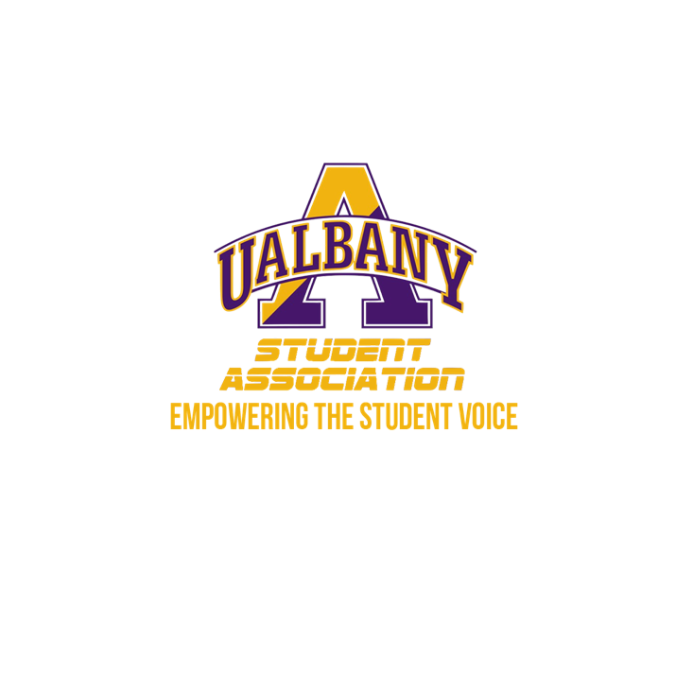

Student Association Board of Finance
Meeting Minutes
February 3rd, 2020 – 10 PM
The HUB Conference Room

- Call to Order and Roll Call
- Approval of the Minutes
  - Motion to Approve – Simon
    - Second – McCracken
- Chairs’ Report
  - Samuel Salazar, Chairman of the Board of Finance
    - applauds everyone for their work at yesterday meeting
  - Molly Donelan, Vice-Chairwoman of the Board of Finance
    - There are some discrepancies, wants to address them in executive sessions
- Comptroller’s Report
  - Tony Kelley, Comptroller
    - No report
- Senate Report
  - Sabra Simon, Chair of the Appropriations Committee
    - No report
- Budgetary Business
  - None
- Unfinished Business
  - Motion to go into executive session by Donelan Second by Zhang without objection, including Chairman Chin, Senator Conway, and Secretary Vesic
- New Business
  - None
- Closing Roll and Adjournment
  - Motion to Adjourn by Donelan
    - Seconded by McCracken

