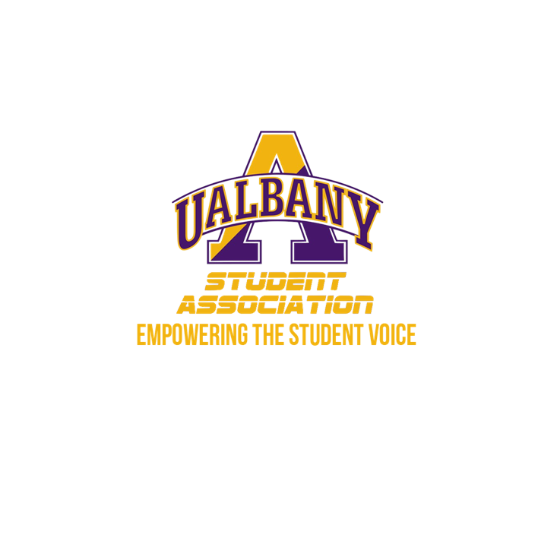

Student Association Board of Finance
Meeting Agenda
November 14th, 2019 – 8PM
The Orb

- Call to Order and Roll Call
- Approval of the Minutes
- Public Comment
- Chairs’ Report
  - Samuel Salazar, Chairman of the Board of Finance
  - Molly Donelan, Vice-Chairwoman of the Board of Finance
- Comptroller’s Report
  - Tony Kelley, Comptroller
- Senate Report
  - Owen Howard, Chairman of the Appropriations Committee
- Budgetary Business
  - Mandatory Budget Meeting Update
  - Presentation of the Budget Template for FY 2020-2021
- Unfinished Business
  - Financial Whistleblower Policy
  - Comptroller Office Review
  - Contract Rubric Revamp Process
- New Business
  - S.1920-BAA
- Closing Roll and Adjournment

