Governing Board
Carolyn Thomas Morris, President
Art Blume, President Elect
Jacqueline S. Gray, Past President
Joanna M. Shadlow, Secretary
Christopher Morris, Treasurer

Society of Indian Psychologists

June 26, 2014

Stephen Behnke, JD, PhD
Ethics Office
American Psychological Association
750 First Street, NE
Washington, D.C.

Dear Dr. Behnke:

Please find enclosed 16 Copies of the Society of Indian Psychologists Commentary on the American Psychological Association (APA) Ethnical Principles of Psychologists and Code of Conduct. Please send payment of $20 per copy (Total: $320) to the Society of Indian Psychologists at the following address:

Christopher Morris, PhD, Treasurer
Society of Indian Psychologists
Open Skies Healthcare
707 Broadway NE, Suite 401
Albuquerque, NM 87102

We would be happy to assist if you need additional copies.

Respectfully,
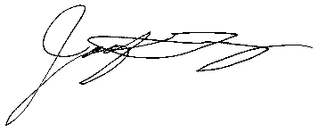

Jacqueline S. Gray, PhD
Past President

