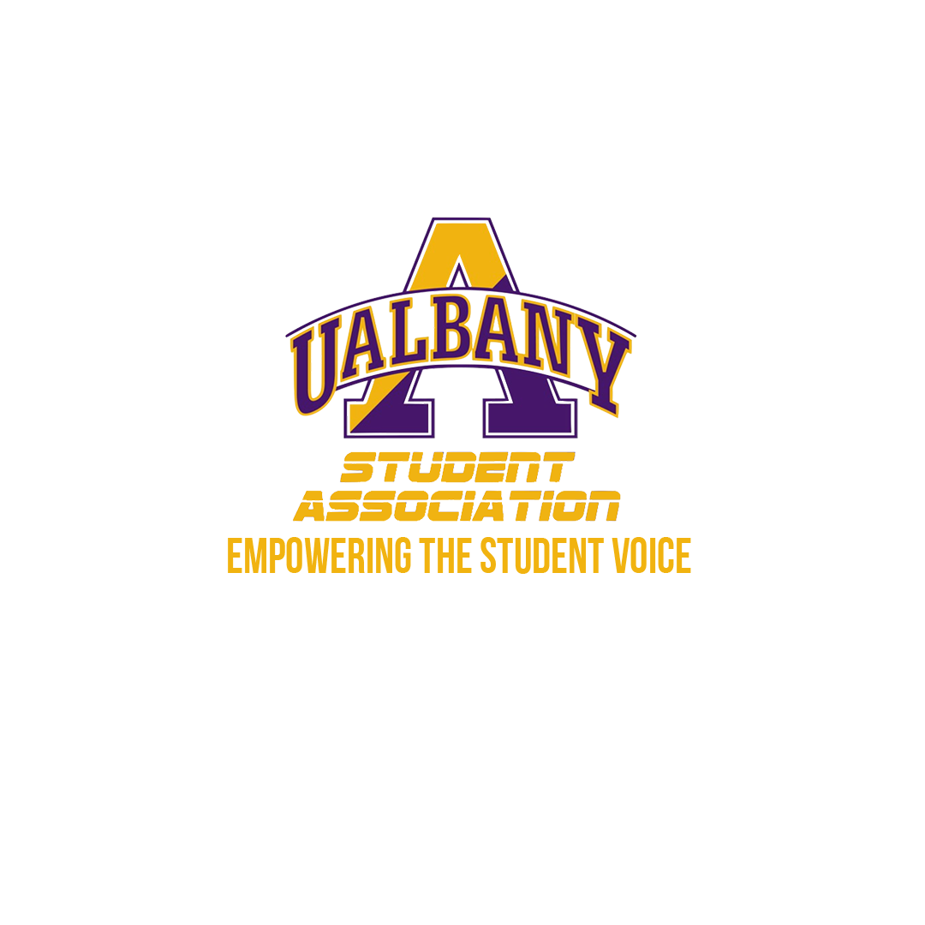

STUDENT ASSOCIATION BUDGETARY MEMO



Dear members of the Senate,

It has been an honor for me to be your Chairman of the Board of Finance for the 2019-2020 academic year. There is no doubt that this year’s Board of Finance has underwent massive projects, investigations, and financial review. I am proud to have led a team of some of the best students at the University at Albany. I am honored to present to you next year’s budget for consideration. There have been significant structural and financial changes to the budget. The first is the overall budget number. The Board of Finance has allotted the Student Association a flat $3,000,000.00. The $3,000,000.00 is meant to be a cap for the Student Association so that there is no uneven amount. The breakdown of the overall budget is 1,789,551.44 for the Internal Budget and 1,210,448.56 for the External Budget. These Budget have been balanced and the appeals process for student groups has undergone thoroughly. More detailed breakdowns of the two budgets can be found in the accompanying pages. I look forward to the official presentation of the Budget on April 8th, 2020 and look for its immediate passage. If there are any questions, please do not hesitate to reach out to me by emailing me at bof@albany.edu

Sincerely,

Samuel Salazar
Chair of the Board of Finance

Student Association Budget for FY 2020-2021

External Budget Breakdown

The total External Budget has increased from $1,024,959.21 to $1,210,448.56. This has been an increase of $185,489.35 which is an 18% increase. Attached you can find some of the major highlights:

- The average Student Organization Budget received a total of $13,600.55.
- The median Student Organization Budget received a total of $6,166.00.
- The average Student Organization Budget increase is calculated to be at 17% which aligns with the overall increase rate.
- The median Student Organization Budget increase is calculated to be at 49% which greatly exceeds the overall increase rate.
- All of the Student Organizations that have received funding were eligible to appeal and those that completed the appeal were properly integrated into the Budgetary System. There was a total of 8 Student Organization appeals that were successful and 4 were unsuccessful.
- A total of 2 new Student Organizations received funding.
- 9 Student Organizations did not submit a budget for consideration.
- 3 Student Organizations submitted a budget late and received the late fee reduction policy which is 10% per day late.
- For more detailed information per Student Organization please refer to the master excel spreadsheet.

Internal Budget Breakdown

The total Internal Budget has increased from $1,707,827.79 to $1,789,551.44. This has been an increase of $81,723.65 which is a 5% increase. Attached you can find some of the major highlights:

- Dippikill received an additional budgetary investment increase of 11%.
- Personnel grew from the standard 2% to 20%. This was a result of increasing some of the lines in the personnel section. There was a restructuring of the Comptroller’s office, as well as new additions in the Executive branch. There was also the reduction of two positions. The average personnel change was 17%. The Median personnel increase was 30%.
- Student Association Operating saw a decrease. This was a result of moving some of the last-minute lines Senate put last year when approved. Conferences have been completely removed from the budget in order to supply the personnel increase. Office supplies received a decrease upon the consultation of the Executive Office Manager.
- Summer Operating received an increase only to a new summer bonding SA initiative by the incoming administration.
- Student Legal Services received the standard 2% personnel increase.
- Insurance received a decrease upon the recommendation of the Comptroller, Executive Office Manager and our spending data this year.
- The Discretionary for the Executive remained the same.
- The Elections commission budget remained the same.
- The Senate’s budget underwent three main changes. The first was the elimination of conferences entirely. The second was a fix in the discretionary spending. The current budget for the fiscal year did not included a line for senate technology for use in the boardroom. This was fixed to reflect necessary changes for next year. The last change was the decrease of the Supplemental Line to a flat amount of $60,000 while increasing New and Unfunded and Sponsorhsip Lines to increase more incorporation of new and starting groups as well as partnering with other non-SA recognized organizations.
- Academic Affairs was given a solid budgetary line. The Affordable Testing Act was moved to this department to execute and reduced by 60%.
- Civic Action was given increases to help with the upcoming 2020 election.
- Community Engagement and Outreach remained the same.
- The Dippikill Department and Outreach received the busses to Dippikill line which was moved from the operating line of the budget. There was an increase in the busses for Dippikill to further allow students access to Dippikill.
- Gender and Sexuality Concerns received a slight increase to help alleviate the cost of big events throughout the year.
- Health and Sustainability received an increase as we moved the former period products line from operating to this department for careful implementation and renamed Health and Wellness products to be more inclusive.
- Intercultural affairs remained the same.
- Marketing received an increase to invest in new computer programs for the department to develop flyers, advertising, etc.
- The Programming Department received an increase in order to invest in programming for students as well as enhance the outlook of Parkfest and Block Party.
- Public Relations saw a decrease of 29%.
- Student Group Affairs remained the same.
- Prior Years remained the same.
- For more detailed information per line please refer to the master excel spreadsheet

