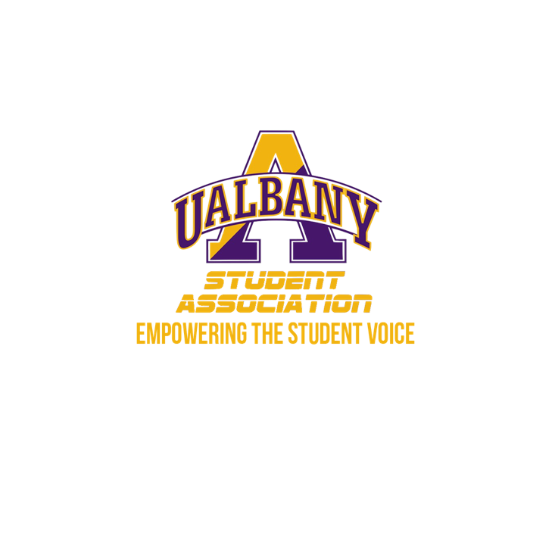

Student Association Board of Finance
Meeting Agenda
April 16th, 2020 – 5:30 PM
Video Conference

- Call to Order and Roll Call
- Approval of the Minutes
- Public Comment
- Chairs’ Report
  - Samuel Salazar, Chairman of the Board of Finance
  - Molly Donelan, Vice-Chairwoman of the Board of Finance
- Comptroller’s Report
  - Tony Kelley, Comptroller
- Senate Report
  - Sabra Simon, Chair of the Appropriations Committee
- Budgetary Business
  - Certification of the Budget
- Unfinished Business
- New Business
  - Audit Report
  - Credit Card Review
- Closing Roll and Adjournment

