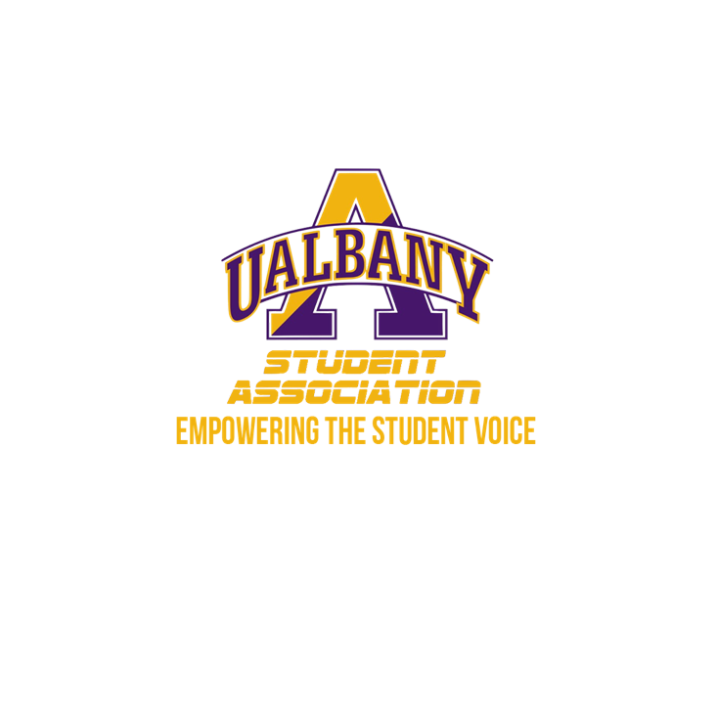

Student Association Board of Finance
Meeting Minutes
October 4, 2019 – 9 AM
The HUB Conference Room

- Attendance
  - Board
    - Present: Molly Donelan, Sam Salazar, Owen Howard, Ivan Daquial, Sabra Simon (called in), Amy Zhang
    - Excused absence: Marielle Apronti
  - Comptroller Tony Kelly – Present
  - Elections Commission Chair: Ankeith Illiparambil – Present
  - Student Activities: Ray Webb, Pamela Alexander – Present
- Motion by Howard to begin (9:14 a.m.)
  - Second – Salazar
    - No objections
- Comptroller reviews BoF guidelines:
  - Started w/ purpose & responsibilities
  - Contract Review
  - Budget proposal process timeline
  - BoF acknowledgement of Viewpoint Neutrality
    - Members signed two documents promising to adhere to SA law, protocol, viewpoint neutrality, and nondisclosure acknowledgement of SA contracts, conversations, etc.
- Pamela clarified Student Activities’ advisory role with the BoF
  - Howard – discussed hotel policy and differing prices for student organizations
  - Kelly – brought up point of a tradition of a max for venue allocations of funding
- Discussion held about GroupMe voting on SA contracts
  - Pamela recommended alterations to the bid/contract authorization form, as well as suggesting not to vote over GroupMe
- Pamela explained process of artist bidding
  - Kelly – asked about process of Speaker Series MOU
  - Pamela – explains MOUs
    - MOU = Memos of Understanding
      - Softer than a contract, still legally binding, but easier to pullout
      - SA has 3 current MOUs
        - No charge to student organizations for CCM space
        - No charge for event staff
        - Speaker Series
      - Several campus partners are stakeholders in the MOU
  - Kelly - clarifies question: Does SA bring MOUs to BOF?
    - Pamela – in NYS, MOUs do not have to go to the state comptroller
      - BoF signs off on contracts over a certain amount
      - Reminds BoF that Sa has 3 members on the Speaker Series board
        - SA has the “majority seat”
  - Daquial – point of inquiry
    - He has an exam at 10:15. BoF leadership elections?
    - BoF decides to pause on meeting to hold election
  - Ankeith Illiparambil, Chair of Elections Commission, leads election
    - Daquial – point of inquiry
      - What satisfies majority?
        - Illiparambil – “4”
    - Salazar – self-nominates for BoF Chair (only candidate)
      - Gives introductory speech to the membership
        - Introduced his background, personally and professionally
        - Talked about his goals as Chair
          - Transparency, work w/ Comptroller
      - Kelly – “What are some deficiencies in SA financial policy?”
        - Salazar – Stipend policy. Some clauses have confusion and conflict between branches
        - Rethink role of the Comptroller
      - Howard – “When would you see a stipend change?”
        - Salazar – looking for the semester, with change next semester
      - Kelly – “Who oversees stipend allocation?”
        - Salazar – wasn’t too familiar
      - Howard – Motion to vote
        - Donelan – Second
      - Salazar – wins Chair election. Next: Vice Chair election
    - Donelan – self-nominates for BoF Vice Chair
      - Gives introductory speech to the membership
        - Introduced her background, personal & professional
          - Nassau County experience
        - Talked about goals as vice chair
          - Reaching out to groups, being consistent
      - Kelly – who can freeze budget?
        - Follow up – who can unfreeze budget?
      - Daquial – motion to vote
        - Howard – second
      - Donelan – wins Vice Chair election
  - Chair – wants to wrap up packet
    - Will communicate via email what anyone misses
    - Membership submits previously signed documents to the Chair
  - Howard – Motion to adjourn
    - Donelan – second

Please note this was the First Board of Finance Meeting and as such the format is off

