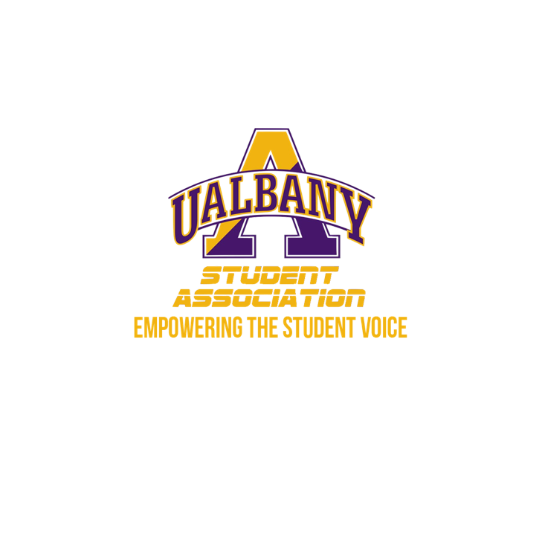

Student Association Board of Finance
Meeting Agenda
April 22nd, 2020 – 9:20 PM
Video Conference

- Call to Order and Roll Call
- Approval of the Minutes
- New Business
  - S.1920-170
- Closing Roll and Adjournment

