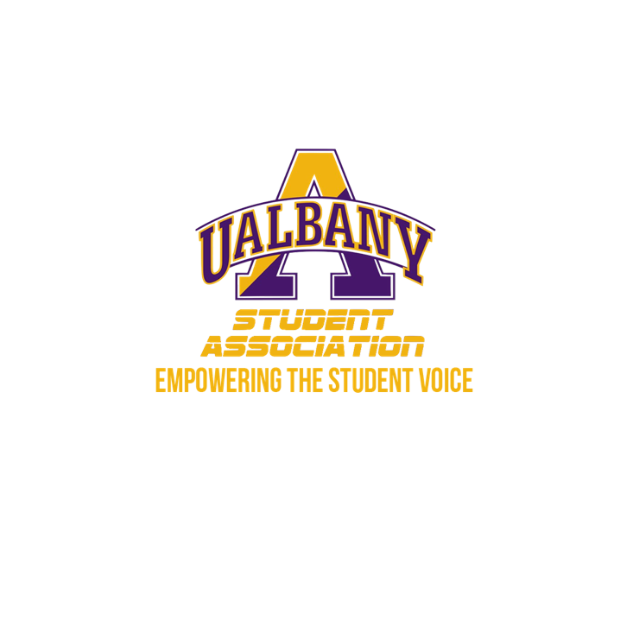

Student Association Board of Finance
Meeting Agenda
February 10th, 2020 – 10 PM
The HUB Conference Room

- Call to Order and Roll Call
- Approval of the Minutes
- Chairs’ Report
  - Samuel Salazar, Chairman of the Board of Finance
  - Molly Donelan, Vice-Chairwoman of the Board of Finance
- Comptroller’s Report
  - Tony Kelley, Comptroller
- Senate Report
  - Sabra Simon, Chair of the Appropriations Committee
- Budgetary Business
  - Myinvolvement update
  - Budget Projection 2020-2021
- Unfinished Business
- New Business
  - Parkfest Contract
- Closing Roll and Adjournment

