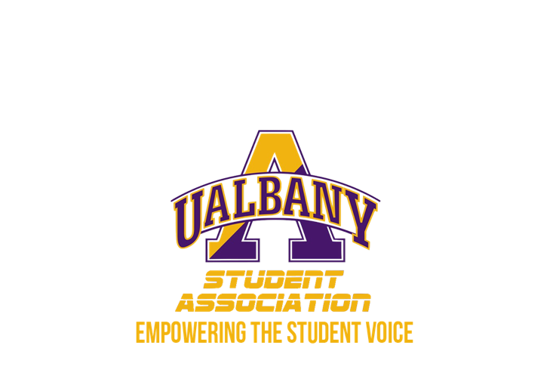

Student Association Board of Finance
Executive Session Minutes
October 24th, 2019
The Orb

- Questions:
  - Daquial: Can the comptroller give a general overview of why the three organizations’ budgets were frozen?
    - Comptroller Kelley-
      - Pulse- had a party that got shut down. We will have a conversation about this. I didn’t know until the university came to me
      - Embrace thy Curls – Had a “fundraiser”, name dropped their organization to police and the University. Charged people for wristbands, allowed alcohol to be served to minors. A bit more difficult to handle. Need to compare all of the stories so we can get to the bottom of this. SA will not tolerate underage drinking. Will follow up on more details
        - Money they made from fundraiser was put back into damages caused. SA money used without SA being made aware
      - Knemesis – They have been a problem since my first day as comptroller.
        - Entered an agreement – they tried to give someone a cash prize for their event from SA budget. Previous comptroller signed off on it. I will not approve cash prize – especially 1k. Entered agreement w/ vendor – made it seem like he was providing a service. We agreed vendor can have the money from their income line. He provided his service. It is not worth the bad press for SA.
        - Treasurer came to me and notified they were having practice at Auden. There was pool table w/ a wobbly leg, and they were informed not to touch it. Pool table broke. Auden charged $1,349 dollars for table. Knemesis e-board asked me “Can we pull from our income line?” I said NO. It was not an SA sponsored practice and it was off campus- nothing to do with us.
        - 2 weeks later (last week) - Pulled into emergency meeting to discuss behavior. Found out Knemesis also had a party. Cannot confirm if it was one or two parties, but definitely at least 1.
        - Money never made it to SA. We didn’t know about it. Authorities were involved and they name dropped their organization
        - They neglected responsibilities they knew they had. Information came to me at least 1 month after it happened
  - Daquial – What are the next steps?
    - Kelley- Pulling them into meetings. Spoke to some of pulse. Spoke to Knemesis full e-board - they had no info to give me. I asked them to tell me everything and they wanted to know what I already knew before sharing anything else… I am going to speak to the University and the organization. We are here for them but we also need to protect SA.. I will go through the proper channels and if need be, make a proper recommendation
  - Howard- Using SA funding to provide stuff for party?
    - Kelley- No. They were just hosting under their organization’s name
  - Salazar – You’ve been dealing with Knemesis since May. The party was the straw that broke the camel’s back?
    - Kelley- Yes.
  - Salazar – Have they shown negativity toward you?
    - Kelley – No, they have been very respectuful. They (maybe) withheld some information but they are understanding and respectful of why their budget was frozen.
  - Howard - If they respect you so much why are they not following the rules?
    - Kelley - They respect me as a person, but not the rules.
  - Daquial – They posted 5 hours ago on Instagram about another event with JAMSA using the SA logo. Have been posting daily. Is this a concern?
    - Kelley - No. We froze them in terms of their budget. So that will not be paid for.
  - Daquial, Follow-up - Would they be frozen as a student group?
    - I am talking to Director of Student Activities and SORC coordinator about that. It is a different path. We are seeing if we have to really do that.
  - Zhang – Have they shown any improvement/accountability?
    - Kelley –
      - Embrace Thy Curls - We have emailed. I have yet to see them or any representative of their organization. They did the most damage.
      - Pulse- came to me immediately. That is what saved them.
      - Knemesis- had to reach out to them. Met with them the next day. Besides that, no communication.
  - Donelan – You mentioned the police were involved. Why?
    - Kelley – Noise complaints, 100+ people
  - Howard – Related to homecoming? Or was this weeks ago?
    - Kelley – Weeks ago
  - Donelan – Did they comply with police?
    - Kelley – Pulse was fine with the police. Have to clarify about knemesis. Hearing conflicting stories.
    - Salazar – Through Student Activities I heard there was a bad interaction with one group and police. I heard alcoholic beverages were thrown at police
    - Kelley – It was described as a scuffle. Unclear if it was knemesis or embrace thy curls. Will fact check. One organization was fighting in the street, we need to clarify the name, but we think it was Knemesis
    - Salazar – Student Activities is discussing halting their MyInvolvement page.
- Executive Session closes - 8:47 p.m.

