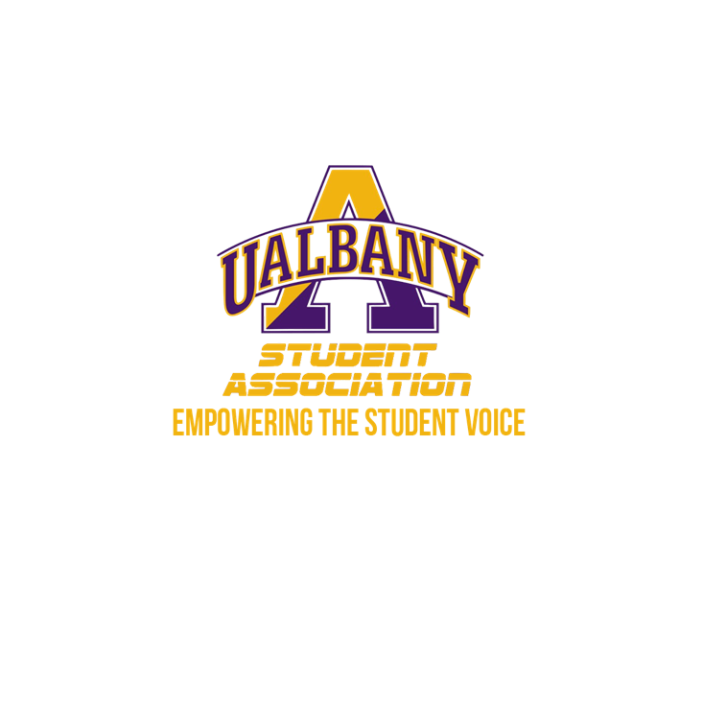

Student Association Board of Finance
Meeting Minutes
January 30th, 2020 – 8 PM
The HUB Conference Room

- Call to Order and Roll Call
  - Motion to approve the Minutes – Donelan
    - Second - Zhang
- Chairs’ Report
  - Samuel Salazar, Chairman of the Board of Finance
    - Salazar – Thank you all for coming. I am going to conduct a training before we continue with the investigation.
  - Molly Donelan, Vice-Chairwoman of the Board of Finance
    - No Report
- Comptroller’s Report
  - Tony Kelley, Comptroller
    - No Report
- Senate Report
  - Sabra Simon, Chair of the Appropriations Committee
    - No Report
- Budgetary Business
  - None
- Unfinished Business
  - None
- New Business
  - Financial Investigation 1
    - Motion to go into Executive Session – Zhang
      - Second Donelan
- Closing Roll and Adjournment

