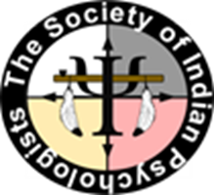 | The Society of Indian Psychologists | Executive Board  President  Gayle Skawen:nio Morse  President Elect - Iva Greywolf Past President – Art Blume  Secretary – Royleen Ross Treasurer – BJ Boyd

April 23, 2019

Dear Cerynn,

We are pleased to inform you that you have permission to recruit and interview participants for your dissertation research entitled: "An Exploration of Indigenous Spiritual Microaggressions", at the Society of Indian Psychologist’s Annual Convention.
For our part the Society of Indian Psychologists will permit in person recruitment. You may have a table where you can have flyers and a private space should you need to interview someone. If you would like a private space please contact Melissa Tehee, the convention coordinator.

With my warmest regards,

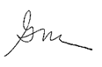

Gayle Skawen:nio Morse, Ph.D.
President, Society of Indian Psychologists

