Domestic Violence Homicide Statistics

When a woman enters a shelter for safety, it may be his life that is saved. 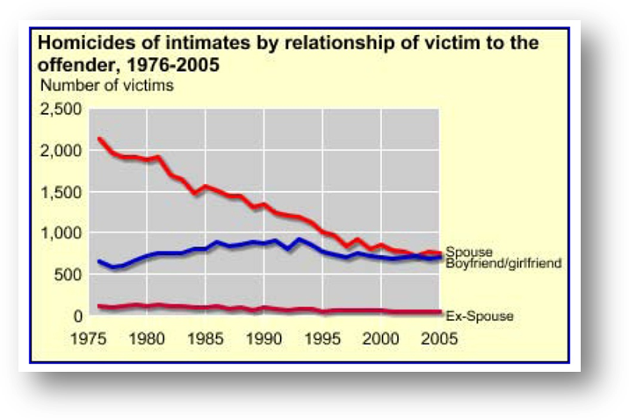
The availability or presence of firearms increases lethality for both genders.

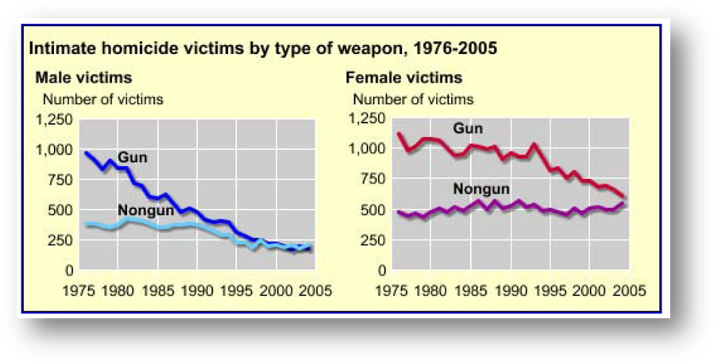

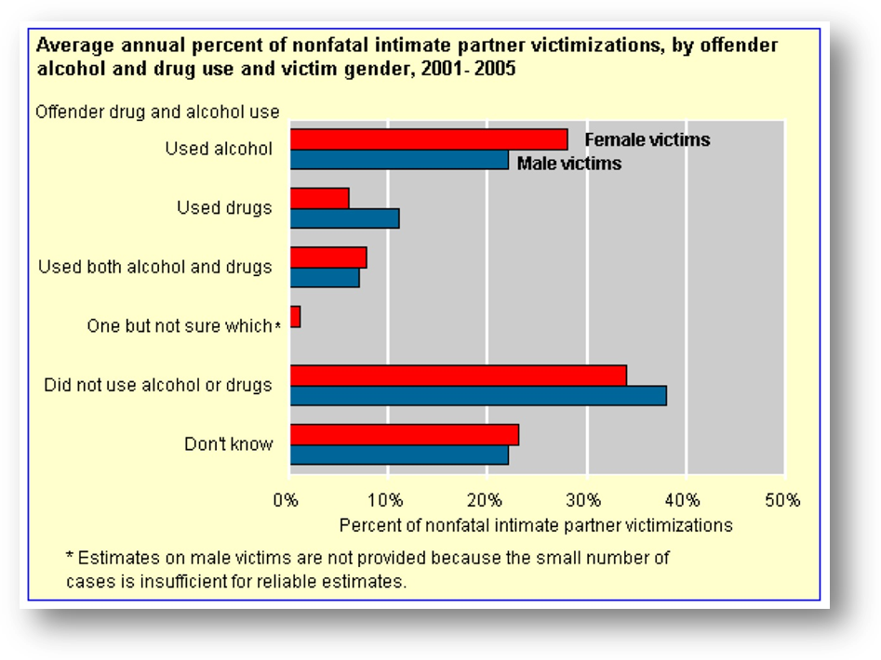

This chart shows that use of alcohol or drugs is not a causal factor; victim reports indicate that domestic violence incidents where the offender is drunk or high result in lesser injury than that of offenders that are sober at the time of the assault.

