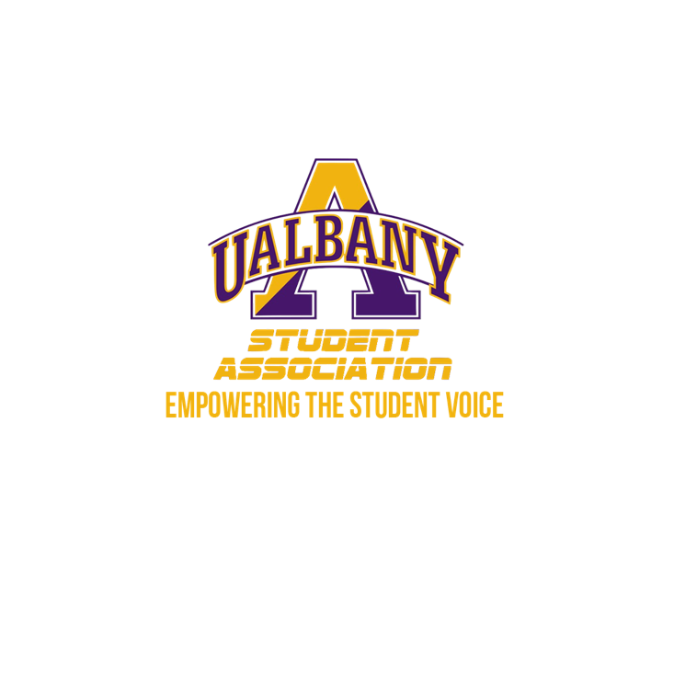

Student Association Board of Finance
Emergency Meeting Agenda
March 11th, 2020 – 9 PM
The HUB Conference Room

- Call to Order and Roll Call
- Approval of the Minutes
- Chairs’ Report
  - Samuel Salazar, Chairman of the Board of Finance
  - Molly Donelan, Vice-Chairwoman of the Board of Finance
- Budgetary Business
- Unfinished Business
- New Business
  - PF 3
- Closing Roll and Adjournment

