TO: Andi Lyons, Chair, Governance Council
FROM: Susanna Fessler, Chair, University Senate 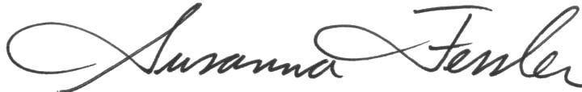
DATE: May 21, 2012
Re: Consultation with the Senate on Retention of the Minors

Chair Lyons,

The report generated by the Governance Council in response to Resolution 1112-03R states in part that:

About whether the President’s response to all stakeholders on March 24, 2011, constituted a “detailed response” to the Senate, reasonable people may continue to disagree. In fact, to date, the President has not sent a formal response specifically to the Senate about the deactivations as required in the bylaws, but has instead relied on his March 24 statement to the university community at large. On the other hand, at the time the Senate should have furnished a more detailed response on the impacts of closing each of these programs for the President to address.

I wish to add some missing information to this picture. Although the President did not send a formal response specifically to the full Senate, the President did meet with the Senate officers (Vice-Chair Fessler, Chair Lifshin, and UPPC Chair Fossett) on March 23 to inform them about his decision to retain the minors, etc. (as detailed in his e-mail to the campus the next day). This is in keeping with the Charter, IV.1.1 that the Chair represents the Faculty Senate. Although not written in the Bylaws or Charter, this is standard procedure in cases when time is of the essence and the full Senate cannot be convened in a timely fashion.

All that said, let me point out that the Bylaws I.2.4.1 state:

Except where precluded by contractual or other legal restrictions, minimally, formal consultation with the faculty on these proposals shall entail consultation between administration and University governance bodies. Formal consultation shall require communication, preferably in writing, specifying the area or issue for which recommendations are being solicited and accompanied by sufficient information as necessary for an informed recommendation. Formal consultation should occur as soon as issues needing resolution are identified. The faculty shall be given adequate time to respond. A written response to final Faculty recommendations shall be provided, indicating what decisions were made and the basis for such decisions; this should be particularly detailed in instances where faculty recommendations are not followed. [emphasis added]

Note that formal consultation was given in writing to the Senate on October 1, 2010. The faculty was given five months to respond. The written response to final faculty recommendations was provided on March 24, 2011. The Bylaws do not require that the President sent his formal response to any specific body. They simply state that a written response…shall be provided. It was a courtesy, therefore, for the President to meet with Senate officers before sending his e-mail of March 24. He should be commended for reaching out to the Senate in this way, thus reinforcing his recognition of the Senate as representative of the faculty.

