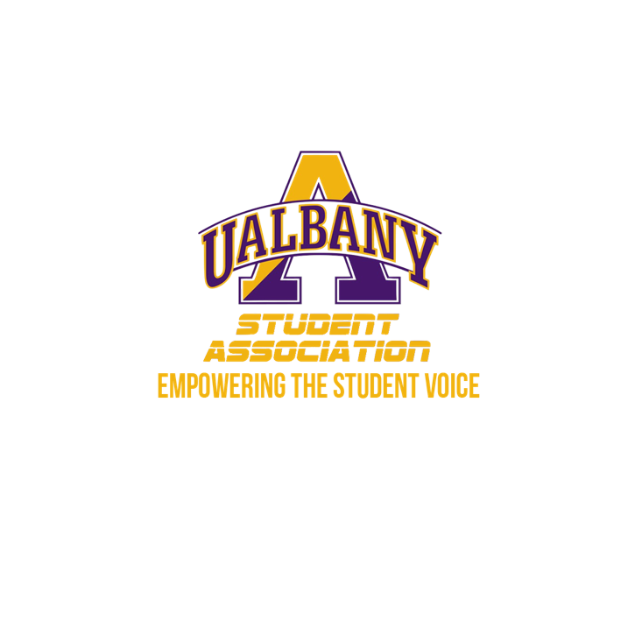

Student Association Board of Finance
Meeting Minutes
February 2nd, 2020 – 4:45 PM
The HUB Conference Room

- Call to Order and Roll Call
- Approval of the Minutes
  - Motion to approve - Simon
    - Second - Amy
- Chairs’ Report
  - Samuel Salazar, Chairman of the Board of Finance
    - No report
  - Molly Donelan, Vice-Chairwoman of the Board of Finance
    - No report
- Comptroller’s Report
  - Tony Kelley, Comptroller
- Senate Report
  - Sabra Simon, Chair of the Appropriations Committee
    - Met with 5 groups, better submissions happy about htat. Thinking about hosting a tutorial for the budget process.
- Budgetary Business
  - None
- Unfinished Business
  - None
- New Business
  - Financial Investigation 1
    - Daquial – Motion to go into Executive Session
    - Zhang - Second
- Closing Roll and Adjournment
  - Motion to Adjourn - Simon
    - Second - Zhang

