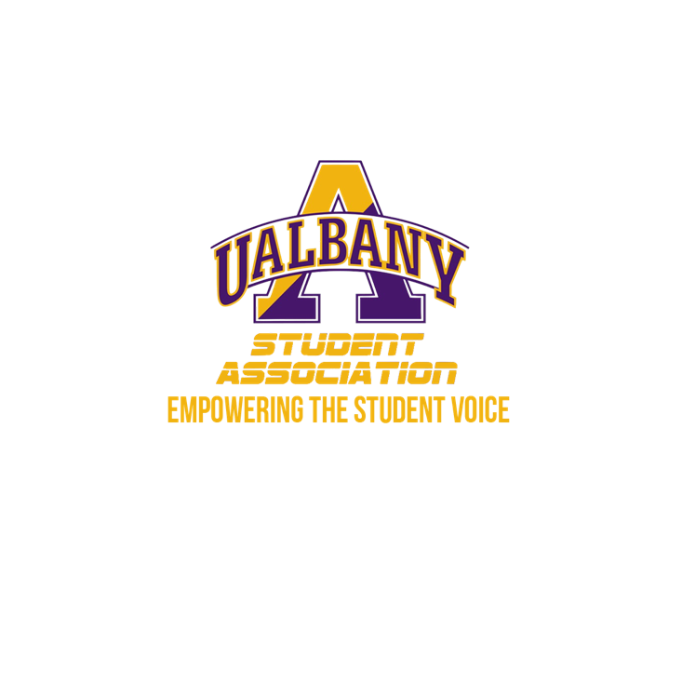

Student Association Board of Finance
Meeting Agenda
February 16th, 2020 – 5 PM
The HUB Conference Room

- Call to Order and Roll Call
- Approval of the Minutes
- Public Comment
- Chairs’ Report
  - Samuel Salazar, Chairman of the Board of Finance
  - Molly Donelan, Vice-Chairwoman of the Board of Finance
- Comptroller’s Report
  - Tony Kelley, Comptroller
- Senate Report
  - Sabra Simon, Chair of the Appropriations Committee
- Budgetary Business
  - Assessment of the proposals
  - Molly’s Groups
    - Albany State University Black Alliance
    - Black Theatre Productions
    - Campus Ambassadors
    - Model EU
    - Kehila
    - Musical Theatre Association
    - Newman Catholic Association
    - UAlbany Debate Team
    - Precizun Step Team
    - Pride Alliance
    - UAlbany Outreach for Animals Club
    - Liga Filipina
    - Cyber Defense Organization
    - Shabbos House Lchaim
    - Students for Sensible Drug Policy
- Unfinished Business
  - Approval of the Budget Rubric
- New Business
- Closing Roll and Adjournment

