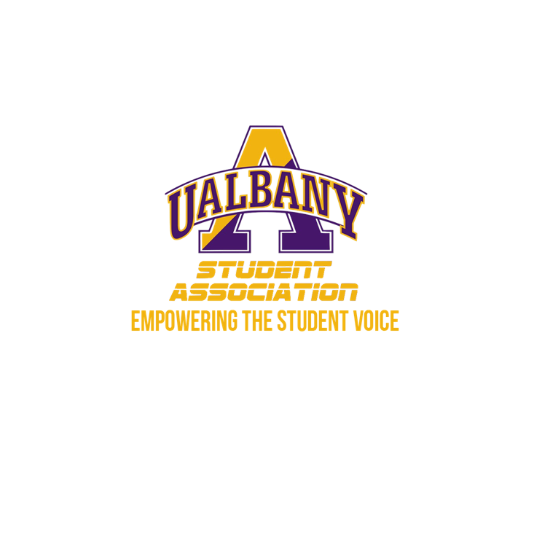

Student Association Board of Finance
Meeting Agenda
November 24th – 1 PM
The HUB conference room

- Call to Order and Roll Call
- Approval of the Minutes
- Public Comment
- Chairs’ Report
  - Samuel Salazar, Chairman of the Board of Finance
  - Molly Donelan, Vice-Chairwoman of the Board of Finance
- New Business
  - Consideration of a Student Activity Fee Amendment
- Closing Roll and Adjournment

