Dear Drs. Anton, Kaslow, McDaniel and Puente,

The national ethnic minority psychological associations, including the Asian American Psychological Association (AAPA), the National Latina/o Psychological Association (NLPA), and the Society of Indian Psychologists (SIP), have been discussing the nature of the role their delegates at the Council of Representative's (COR) meetings. As you recall, the national ethnic minority psychological associations were invited to send delegates to COR to attend and offer expertise of our respective groups that would be helpful for Council representatives in their deliberations, the outcomes of which impact psychologists across the United States regardless APA membership. There was also hope that our groups would obtain a voting seat on COR at some point.

The vote to gain seats for delegates from national ethnic minority psychological associations did not pass, despite several attempts and the support of COR representatives, and the role of our delegates to COR has become less clear. As a result, the national ethnic minority psychological associations request that the value of sending their delegates be enhanced through development of opportunities to collaborate more meaningfully at COR and offer the following suggestions to increase delegate participation for your consideration:

- National ethnic minority psychological associations’ delegates be included in the role call, with their status as delegates duly noted, which would highlight the presence, role, and expectation of participation of delegates within COR.
- National ethnic minority psychological associations’ delegates be afforded an opportunity to participate in the drafting of motions and commenting upon motions prior to their being brought to the floor for voting. National ethnic minority psychological associations’ delegates were afforded this opportunity for the post-independent review motions, which represented an effective collaborative model.
- National ethnic minority psychological associations’ delegates be afforded an opportunity to participate in votes and that their votes be indicated separately from COR member votes in the tallies on the screen which will provide better opportunities to include the perspectives of the ethnic minority psychological associations in a separate category.
- COR voting items requiring public comment have a specific section for national ethnic minority association comments, apart from APA Boards and Committees and general public comments, for targeted solicitation of input and that the items be sent, via the delegates, to national ethnic minority association governance boards with a request for input.

It is our hope that these changes will provide systematic and salient opportunities for delegates to promote collaboration between the American Psychological Association and the ethnic minority associations.

Thank you for considering our request. We look forward to discussing these suggestions and your contributions regarding how to enhance opportunities for more meaningful participation of ethnic minority psychological associations’ delegates in COR activities.

Sincerely,



Marie L. Miville, PhD, President Y. Evie Garcia, PhD, COR Delegate
National Latina/o Psychological Association National Latina/o Psychological Association

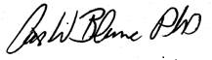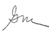

Art Blume, PhD, President Gayle S. Morse, PhD, COR Delegate
Society of Indian Psychologists Society of Indian Psychologists

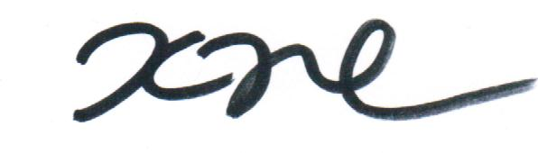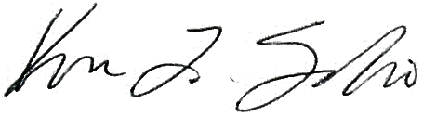

Kevin Nadal, PhD, President Karen L. Suyemoto, PhD, COR Delegate
Asian American Psychological Association Asian American Psychological Association

