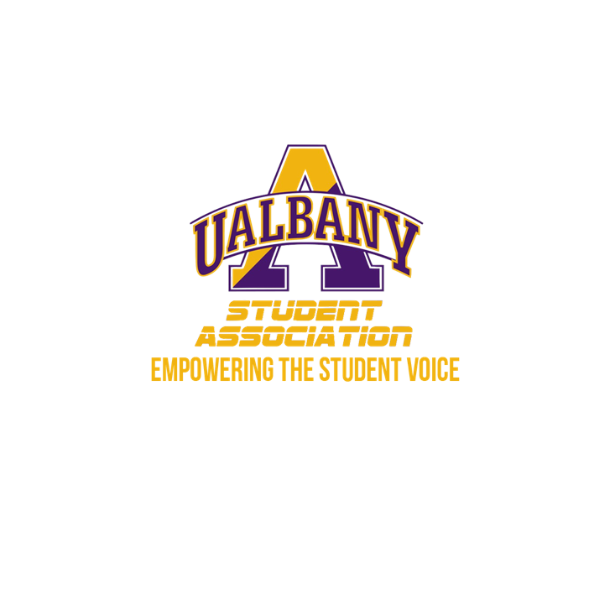

Student Association Board of Finance
Meeting Agenda
March 26th, 2020 – 6 PM
Video Conference Call

- Call to Order and Roll Call
- Approval of the Minutes
- Public Comment
- Chairs’ Report
  - Samuel Salazar, Chairman of the Board of Finance
  - Molly Donelan, Vice-Chairwoman of the Board of Finance
- Comptroller’s Report
  - Tony Kelley, Comptroller
- Senate Report
  - Sabra Simon, Chair of the Appropriations Committee
- Budgetary Business
  - Dippikill
  - Personnel
  - Student Association Operating
  - Student Association Summer Operating
  - Student Legal Services
  - Insurance
  - Office of the President
  - Office of the Vice-President
  - Elections Commission
  - Supreme Court
  - Student Association Senate
  - Civic Action
  - Community Engagement and Outreach
  - Gender and Sexuality Concerns
  - Health and Sustainability
  - Intercultural Affairs
  - Marketing Office
  - Programming Office
  - Public Relations
  - Student Group Affairs
  - Prior Years
- Unfinished Business
- New Business
- Closing Roll and Adjournment

