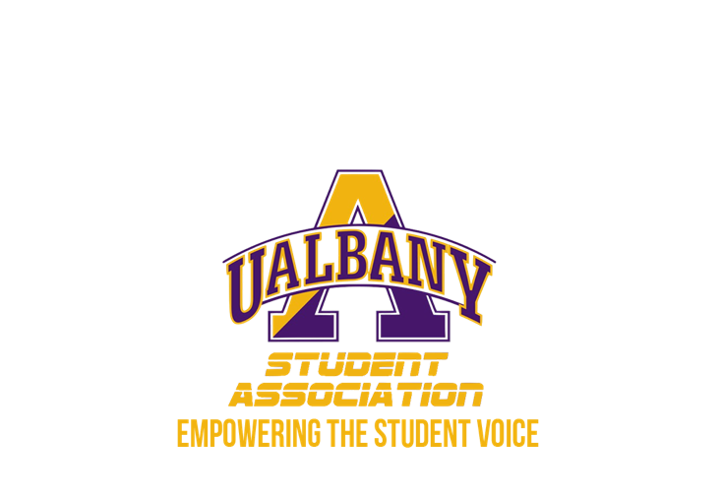

Student Association Board of Finance
Meeting Minutes
October 24th, 2019 – 8PM
The Orb

- Call to Order and Roll Call
- Approval of the Minutes
  - Daquial – Motion to Approve
    - Howard – Second
- Public Comment
  - None
- Official Board of Finance Photo
- Chairs’ Report
  - Samuel Salazar, Chairman of the Board of Finance
    - We have released the flyer for the Budget Orientation for student groups. Please promote!
    - We have set regularly scheduled meetings for rest of the semester
    - We will prepare for budget meeting
  - Molly Donelan, Vice-Chairwoman of the Board of Finance
    - No report
- Comptroller’s Report
  - Tony Kelley, Comptroller
    - I have frozen the budgets of 3 organizations
      - Knemesis
      - Pulse
      - Embrace Thy Curls
    - Donelan - Motion to go into Executive Session
      - Howard - Second
- Senate Report
  - Owen Howard, Chairman of the Appropriations Committee
    - Made excel sheet last night tracking everything. All 3 lines, how much we have spent, how much we have left
    - Form has been live. New Bylaw
      - Daquial – we cut supplemental line significantly last year. How much?
        - Howard -Explains excel sheet
      - Salazar- are you going to make pie charts?
        - Howard - Yes, going to look into it
- Consideration of the weekend Senate budget dates
  - Salazar- Better to do things on the weekend so we don’t rush the budget process.
    - For the Senate budget meeting – One Saturday 9-6, or Two Saturdays, One for external, one for internal?
    - It would not be a session. No reports. Only budget.
      - Zhang- We should do April 18th because the 25th is the beginning of Ramadan.
      - Simon- are we allowed to ask people if they observe orthodox info?
        - Salazar - We will send the dates out, and they can communicate conflicts. Saturday we would not have timing issues with CCM.
      - Comptroller- this is great, we can get it done in one day
    - Zhang – Motion to approve April 18th as the Senate Budget Session
      - Simon – Second
- Liaison assignments communication
  - Salazar- How was this done in the past?
    - Howard- We had the meeting, spreadsheet, questions, etc. Once we approve it, we will inform the student groups and make them aware of the appeals process. Emailing groups beforehand the link and deadlines. We took off 5% every day they were late.
  - Salazar - Did you introduce yourselves to your groups before the budget meeting?
    - Simon, Howard - Yes
  - Salazar - Since I have access to MyInvolvement, I will grab the student group President and Treasurer emails beforehand and email them to you all. We can draft a standard email for informing them of the budget meeting.
    - Kelley- I can send it out to my listerv of the signatories
- Budget Orientation
    - Salazar - It will be held 12/02/2019 7-8pm. I will create a PowerPoint in 2 weeks and show you all.
    - BIG THIS YEAR – the RSVP is very important. Gives us emails and all info- easier for our records.
    - MUST MAKE SURE ITS PROMOTED. Asked CCM to put flyer on TVs. SORC will also be promoting it. I will not hear excuses about groups not being informed.
- MyInvolvement Finance Pilot Program
    - Salazar - Watched new video about budget requests. I saw it; it looks good. Good thing is that we don’t need to send the emails, MyInvolvement will do the work for us. I want to roll out the demo to see if we can do that this year
      - Kelley- This tool will save us astronomical amounts of time.
    - Salazar - I will get the demo from Pamela Alexander
- Unfinished Business
  - Comptroller Office Review
    - Salazar - Motion to table indefinitely
      - Donelan - Second
- New Business
  - Meeting date for the Spring 2020 semester
    - Salazar - How long did you spend per meeting?
      - Simon, Howard - 3-4 hours.
    - Salazar - Comfortable w Sundays?
      - Howard - We have to. There is no time during the week
    - Board unanimously decides on Sundays for Spring 2020 meetings.
  - Contract Review Revamp Process
    - Salazar - Tabling this because I need to speak to Dawn. The rubric hasn’t been updated in 6-7 years.
  - Credit Card Review
    - Board briefly views available credit card statements
  - Financial Whistleblower Policy
    - Table for next meeting
- Closing Roll and Adjournment
  - Howard – Motion to adjourn
    - Zhang - Second

