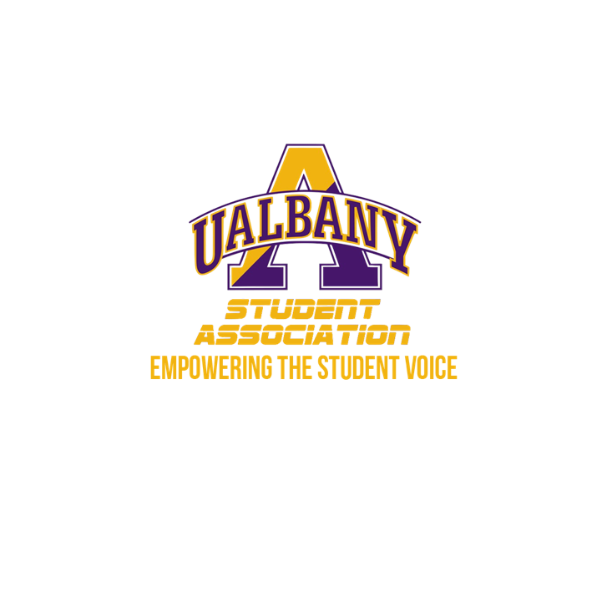

Student Association Board of Finance
Meeting Agenda
March 1st, 2020 – 5 PM
The HUB Conference Room

- Call to Order and Roll Call
- Approval of the Minutes
- Public Comment
- Chairs’ Report
  - Samuel Salazar, Chairman of the Board of Finance
  - Molly Donelan, Vice-Chairwoman of the Board of Finance
- Comptroller’s Report
  - Tony Kelley, Comptroller
- Senate Report
  - Sabra Simon, Chair of the Appropriations Committee
- Budgetary Business
  - Ivan’s Groups
    - African Student Association
    - Amnesty International
    - College Republicans
    - turning Point USA
    - Jamaican Student Association
    - Cornerstone Protestant Campus Ministry
    - National Association of Black Accountants
    - Pan Caribbean Association
    - Albany Sports Business Organization
    - Organized C.H.A.O.S.
    - Women Excelling in Business
    - UAlbany Veterans
  - Marielle’s Group’s
    - Albany Society of Physics Students
    - Angelic Voices of Praise
    - Dance Council
    - Doctors IV Hope
    - Hillel
    - International Association of Emergency Managers
    - Japanese Student Association
    - Pitch Please!
    - Serendipity
    - The Guild
    - Torch Yearbook/Photo Services
    - Two and a Half
    - UAlbany Sustainability
    - Under Construction
    - Umoja
    - MAP
- Unfinished Business
- New Business
  - JAMSA Contract
- Closing Roll and Adjournment

