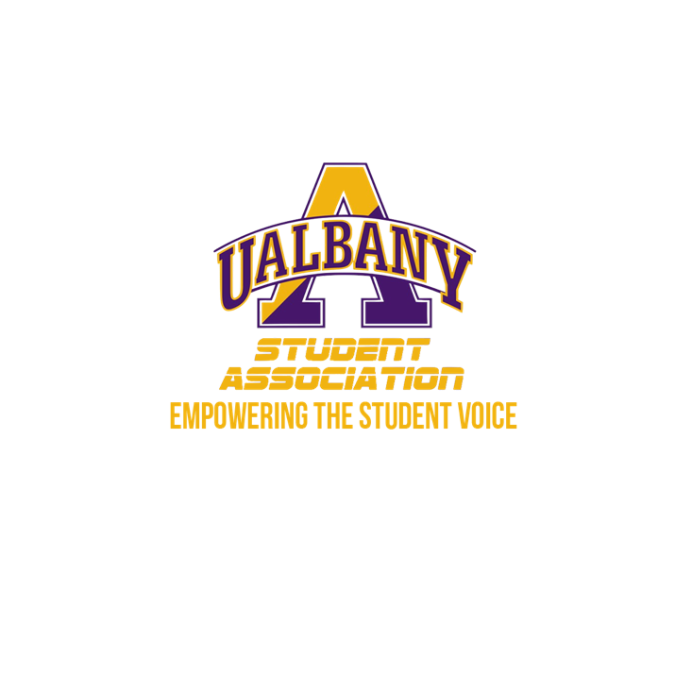

Student Association Board of Finance
Meeting Minutes
January 26th, 2020 – 5 PM
The HUB Conference room

- Call to Order and Roll Call
- Approval of the Minutes
  - Daquial - Motion to approve the minutes
    - Simon - Second
  - No objections
- Public Comment
  - None
- Chairs’ Report
  - Samuel Salazar, Chairman of the Board of Finance
    - Welcome Back everyone!
    - SAFRA – 2020
      - SA Financial Reform Act – Planning to make a financial bylaw overhaul
      - Will present to the Board of Finance next week after investigation is over
    - Budget Rubric
      - We are trying to redo the Budget rubric
    - Contract Rubric
      - Same thing we are redoing the rubric
      - Zhang: Contract Rubric – Btw groups and vendors?
      - Salazar - Any contract over 8k we need to review, better to have a rubric
      - Zhang - Sometimes big orgs Collab with other orgs start getting into heated debate of who pays.
      - Salazar - The rubric is for internal use, whether contract should be accepted by SA
      - Zhang - This is something we try to implement with SGA, to alleviate disputes. We can do a partnership and her department would need to spearhead that

  - Molly Donelan, Vice-Chairwoman of the Board of Finance
    - Congrats Ivan
    - Speak slowly
- Comptroller’s Report
  - Tony Kelley, Comptroller
    - Met with internal controls
    - Meeting with all officers of SA due to internal happenings
    - Went smoothly, impressed w our work
    - Audit is underway
    - Able to successfully get money back from the vendor – about 2k – due to overpayment – Pat paid someone twice on accident
    - We should have a clean bill of health
    - Parkfest – trying to solidify artist. Will probably be more than 1 artist, rather large contracts. Reminding everyone of confidentiality. We have to keep it locked down like Fort Knox. Hopefully we can have 1 big contract but also smaller itemized ones so you can see everything involved.
    - Requesting money from surplus –Joy is putting in a formal request. I will go over it and then bring it to you guys so we can make a formal process because this is unprecedented
- Senate Report
  - Sabra Simon, Chair of the Appropriations Committee
    - We had 5/6 groups come today. 3 we tabled. Denied one and approved another
    - Daquial - New and unfunded?
    - Simon - Don’t have numbers on me at this moment but I will email you
- Budgetary Business
  - Recap of the Mandatory Budget Meeting
    - Meeting was a success, everyone did great, check in was good
  - Review of the Budget Calendar
    - Reread email with the dates of the budget schedule, be flexible!
  - Email expectations
    - Communicate to your student groups however you want – just get the job done
  - Income projection of the Student Association for FY 2020-2021
    - Met with Ray and need to meet with Pam. Enrollment at all time low. Going from 2.7 million dollars to 2.5 and 2.6. million dollars. Not official yet. That’s how it looks right now. We will still pass a budget but difficult decisions will need to be made
    - Form goes live tomorrow at 9 AM. 10% cut each day late!
    - Improved template! looks cleaned up from last year.
- Unfinished Business
  - None
- New Business
  - Financial Investigation 1
    - Motion to go into Executive Session - Zhang
    - Second - Simon
    - Any objections to keeping the Chair of the Student Association Senate in the room?
    - No objections
  - Financial Investigation 2
    - Committed and Sent to the Oversight and Reform Committee
- Closing Roll and Adjournment
  - Motion to Adjourn – McCracken
  - Second - Simon

